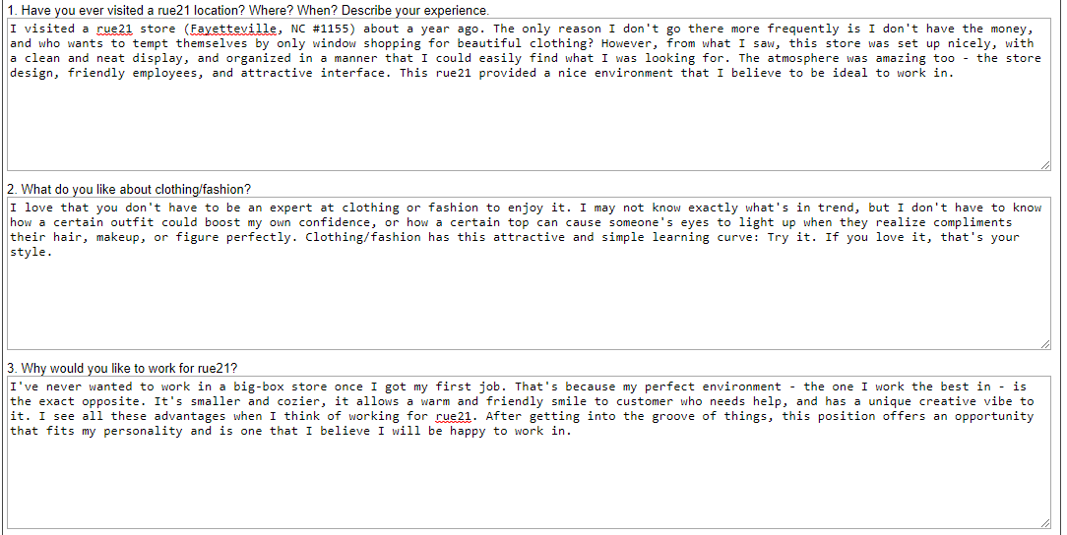

I’ve never wanted to work in a big-box store once I got my first job. That’s because my perfect environment – the one I work best in – is the exact opposite. It’s smaller and cozier, it allows a warm and friendly smile to a customer who needs help, and has a unique creative vibe to it. I see all these advantages when I think of working for rue21. After getting into the groove of things, this position offers an opportunity that fits my personality and is one that I believe I will be happy to work in.